What will we be learning?  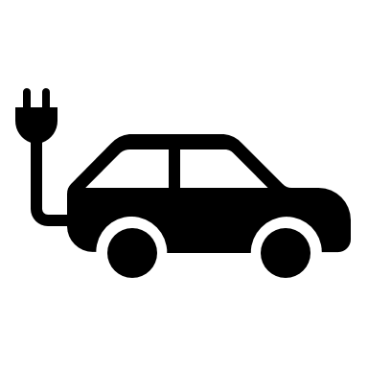  Energy Costs | Why this? Why now?  Previous Learning  Key stage 2 Science  Speed, Gravity, Current, Voltage and Resistance, Energy transfers and Energy costs  Future Learning  Year 8 Course – Light, sound, contact forces, Pressure, Magnetism, Wave effects, electromagnetism  Enquiry Processes  Identify variables, Collect data, Present data, Analyse Patterns, Draw conclusions, Justify opinions and conclusions | Key Words:  Efficiency  Dispersion  Convection  Conduction  Insulators  Conductors  Energy  Kilowatt  Power  Specific heat capacity  Renewable  Non-renewable  Dependency  Demand
What will we learn?
Renewable and non-renewable methods of obtaining energy
The advantages and disadvantages of renewable and non-renewable energy source
How to use data to evaluate the social, economic and environmental consequences of using a resource to generate electricity
The actions a government or communities could take in response to rising energy demand
How to define the term kWh and understand that this represents one unit of electricity
How to calculate the cost of home energy usage using the formula: cost = power × time
How to compare the energy usage and cost of running different home devices
How to use data to suggest ways to reduce energy costs
How to safely conduct an experiment to show energy transfer from food to a beaker of water
Plot a bar graph showing the energy content of different foods
How to use the specific heat capacity equation to calculate energy transfer from burning food to water
To evaluate an experiment to show the energy values of different foods

Misconceptions in this topic
Energy can be lost or gained
Things use up energy
An object at rest has no energy

What opportunities are there for wider study?
Careers - Engineer, Environmental Scientist
STE(A)M – For details of courses and opportunities look at:
https://highcliffe.sharepoint.com/sites/LearnSTEM
How will I be assessed?
End of topic assessment

